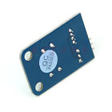**Standard Button Switch Electronic 1pc Sensor Brick Module For Arduino Compatible**

**Electronic 1pc Standard Button Switch Sensor Brick Module For Arduino Compatible**

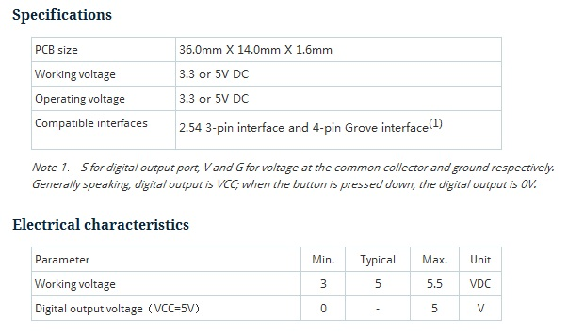

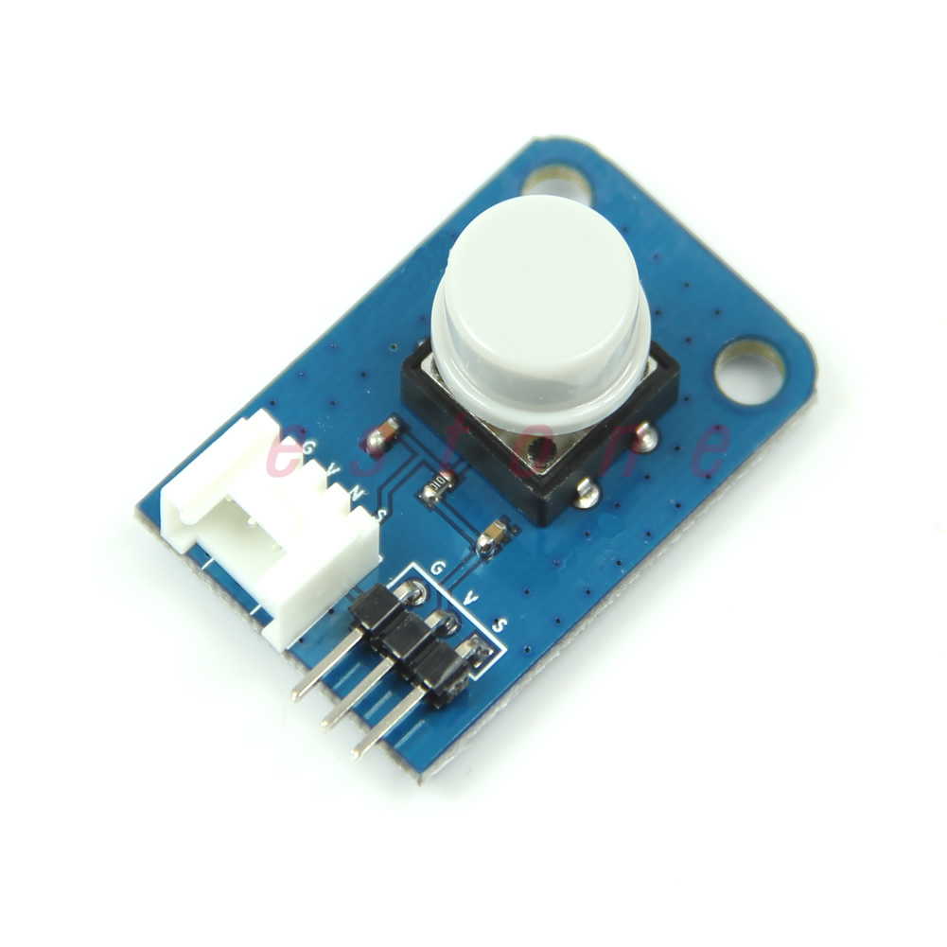 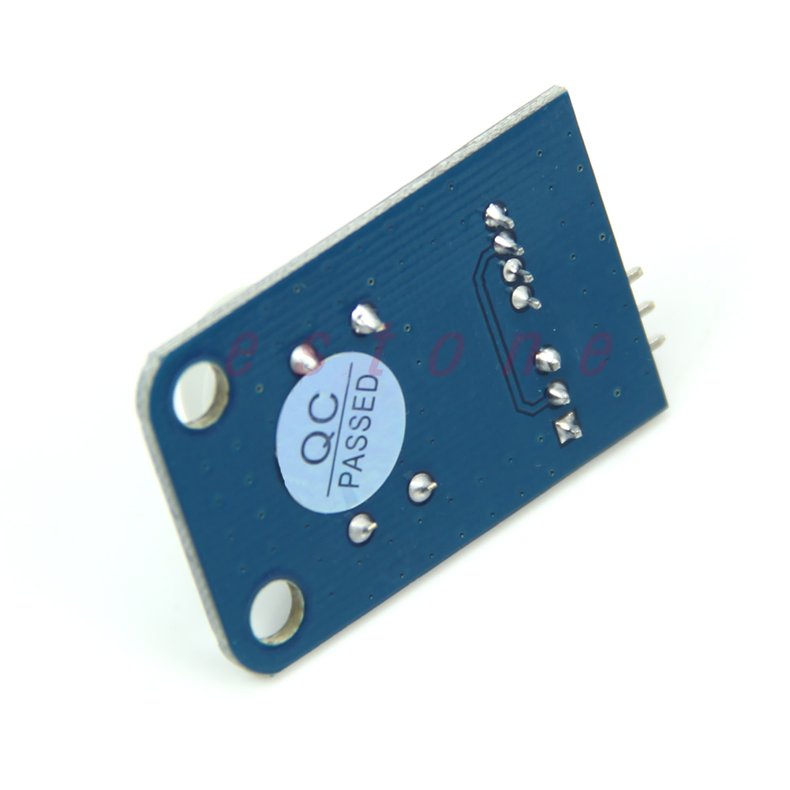 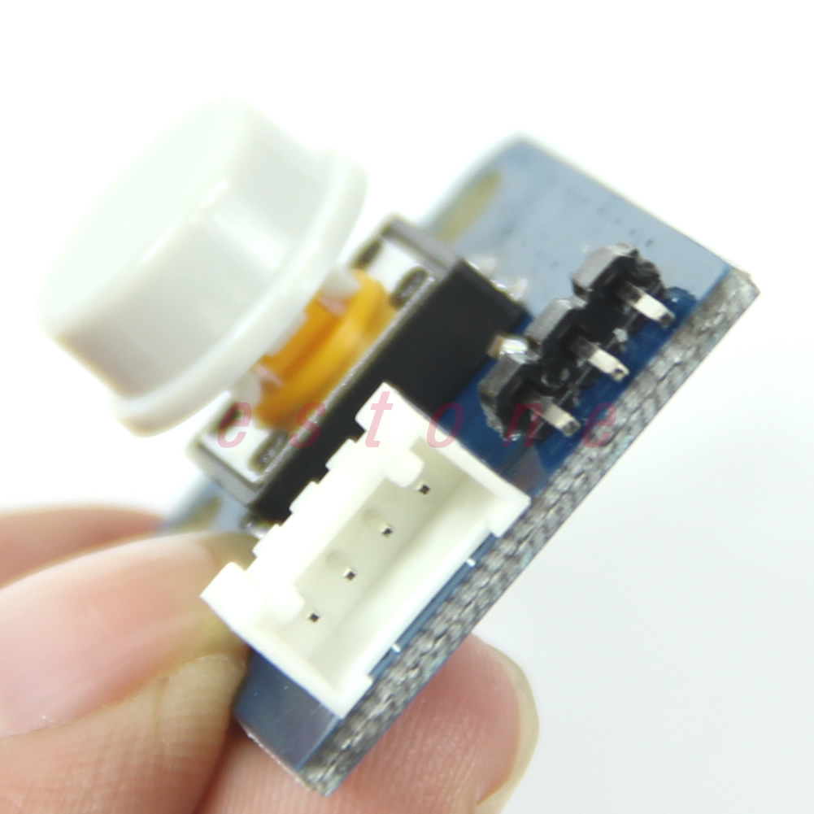 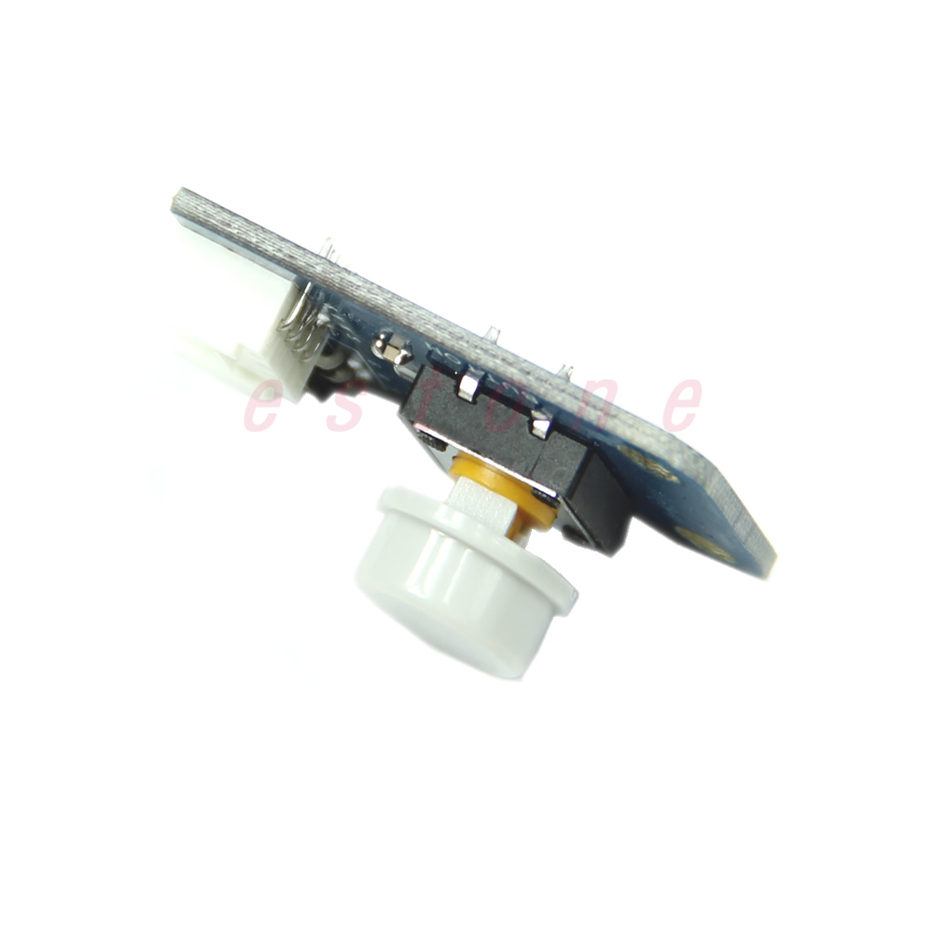

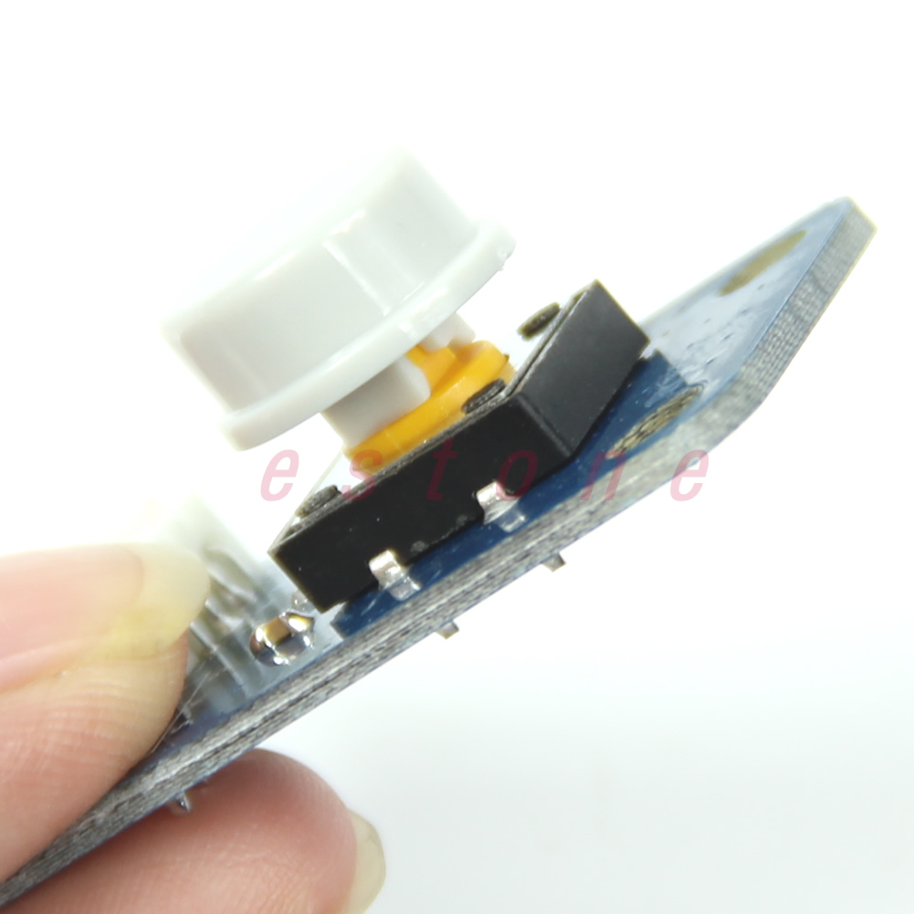

**Description:**

* **100% brand new and high quality**
* Quantity:1pc
* Weight:10 g
* Color: as picture show
* Size:35mmx23mmx1mm/1.38"x0.91"x0.04"(inch) (approx)
* What is an electronic brick? An electronic brick is an electronic module which can be assembled like Lego bricks simply by plugging in and pulling out. Compared to traditional universal boards and circuit modules assembled with various electronic components, electronic brick has standardized interfaces, plug and play, simplifying construction of prototype circuit on one’s own. There are many types of electronic bricks, and we provide more than twenty types with different functions including buttons, sensors, Bluetooth modules, etc, whose functions cover from sensor to motor drive, from Ethernet to wireless communication via Bluetooth, and so on. We will continue to add more types to meet the various needs of different projects.
* Electronic brick of button switch is finger-sized, which can be connected to I/O port of main board or externally disconnected to check the switch state so as to control ON/OFF of LED lamp.
* **Features:**
* 1. Plug and play, easy to use. Compatible with the mainstream 2.54 interfaces and 4-Pin Grove interfaces in the market.
* 2. With use of M4 standard fixed holes, compatible with M4-standard kits such as Lego and Makeblock
* 3. Hardware with debouncing function for more stable output
* 

**DEMO**

Connect S port of electronic brick of button switch to D2 port of Arduino board, and we will use the following program to read the digital value. When the digital value is high level, LED lamp will be ON; when the digital value is low level, LED lamp will be OFF.

int Button=2; //connect button to D2

int LED=13;

void setup()

{

pinMode(LED, OUTPUT);

pinMode(Button, INPUT);

}

void loop()

{

if(digitalRead(Button)==HIGH) //when the digital output value of button is high, turn on the LED.

{

digitalWrite(LED, HIGH);

}

if(digitalRead(Button)==LOW) //when the digital output value of button is low, turn off the LED.

{

digitalWrite(LED, LOW);

}

}